NCTE COLLEGE CODE- APW0340/723100
NRrhlx<+ ;qok fodkl laxBu f’k{k.k lfefr }kjk lapkfyr
¼mPp f’k{kk foHkkx ls ekU;rk izkIr ,oa ia- jfo’kadj 'kqDy fo’ofo|ky; ls LFkk;h lac/n½
foiz dyk okf.kT; ,oa 'kkjhfjd f’k{kk egkfo|ky;
fo’ofo|ky; ifjlj ds cktw] Mwej rkykc] jk;iqj ¼N-x-½
E-Mail vipracollege1996@gmail.com Visit on- www.vipracollege.org
iath;u dza-&17951 Phone No. 9406082000

Consolidated Bio-data in Respect of Staff Appointed by the Institution
S. No. | Name | Designation | B.Ed. % Age | M.Ed./ M.A. Edn % Age | PG Subject & % Age | NET/ SLET/ Ph.D. Subject | Date of Appointment | Status (Regular/ ad hoc/ contract) | Scale of pay | Experience |  | Attached Photograph
 |  |  |  |  |  |  |  |  |  | Teacher training institution | School
1 | Dr. Meghesh Tiwari | Principal | - | - | 79% | Ph.D. | 23/12/2008 | Under Sec 28 | 12000-375-18000 | 23 Years | -
2 | Dr. Divya Sharma | Assistant Professor | 69% | 60% | 69% | Ph.D. Education | 28.04.2011 | Under Sec 28 | 800/-275-13500/- | 11 Years | 2 Years
3 | Mrs. Rasika Malviya | Assistant Professor | 73% | 65% | 50% | - | 28.04.2011 | Under Sec 28 | 800/-275-13500/- | 12 Years | 2 Years
4 | Mrs. Suman Pandey | Assistant Professor | 73% | 63% | 71% | - | 28.04.2011 | Under Sec 28 | 800/-275-13500/- | Nil | 9 Years
5 | Mrs. Reena Shukla | Assistant Professor | 70% | 67% | 56% | - | 28.04.2011 | Under Sec 28 | 800/-275-13500/- | 7 Years | 2 Years
6 | Mrs. Sarika Trivedi | Assistant Professor | 72% | 67% | 57% | - | 30.04.2016 | Under Sec 28 | 800/-275-13500/- | 2 Years | - | 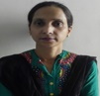
7 | Mrs. Sudha Soni | Assistant Professor | 76% | 70% | 66% | - | 30.04.2016 | Under Sec 28 | 800/-275-13500/- | 7Years | 3 Years | 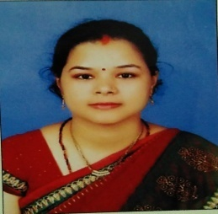
8 | Mrs. Chetna Sharma | Assistant Professor | 76% | 68% | 68% | - | 30.04.2016 | Under Sec 28 | 800/-275-13500/- | - | 3 Years
9 | Mrs. Shweta Jain  (Fine Arts) | Assistant Professor | 63% | - | 70% | - | 30.04.2016 | Under Sec 28 | 800/-275-13500/- | - | - | 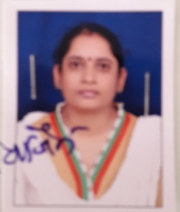
10 | Dr. Manoj Thakuri | Assistant Professor | 69% | 67% | - | NET June 2012 | 30.04.2016 | Under Sec 28 | 800/-275-13500/- | - | 2 Years | 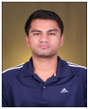
11 | Mrs. Rekha Upadhayay | Assistant Professor | 76% | 73% | 65% | Ph.D.  1995 | 20.06.2008 | Under Sec 28 | 800/-275-13500/- | 13 years | - | 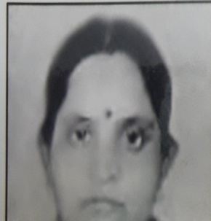
12 | Mrs. Suchita Sharma | Assistant Professor | 65% | 62.7% | 59.8% | - | 20.06.2008 | Under Sec 28 | 800/-275-13500/- | 09 years | -
13 | Mrs. Varsha Sharma | Assistant Professor | 61.9% | 63% | - | - | 20.06.2008 | Under Sec 28 | 800/-275-13500/- | 09 years | - | 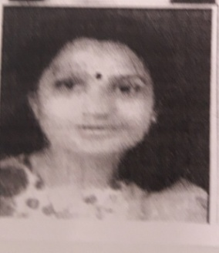
14 | Mrs. Geetika Piyush | Assistant Professor | 63.2% | 63.25% | 67.8% | - | 20.06.2008 | Under Sec 28 | 800/-275-13500/- | 09 years | - | 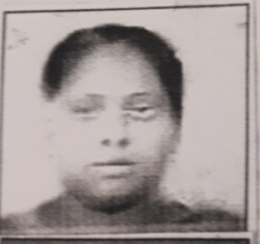
15 | Dr. (Smt.) Bhawna Shukla | Assistant Professor | 64.5% | 67.3% | 59.5% | Ph.D. | 28.04.2011 | Under Sec 28 | 800/-275-13500/- | 06 years | - | 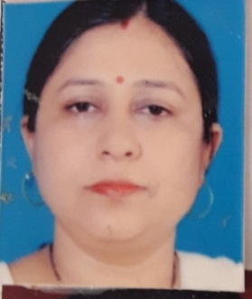
16 | Suresh Bera | Assistant Professor | 74.5% | 63.6% | 65.6% | - | 30.04.2016 | Under Sec 28 | 800/-275-13500/- | 07 years | - | 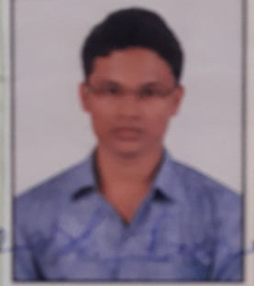
17 | Dr. Shanti Lata  Francis | Head of Department | 72% | 72% | 59% | Ph.D. Education | 27.04.2012 | * | 16400-450-22400/- | 20 Years | 22 Years | 